Creating connection with sqlite:



Retrieving data from db using pandas and sqlite



**Data cleaning:**

One of the major thing in data cleaning is removing **duplication.** Below image shows how to do them.

* First sort on the basis of the column that is kind of unique.



* Second remove duplicates

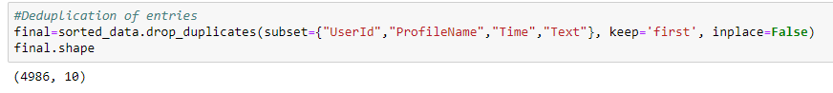

* Finally checking how much %age of data remains after removing duplicates.

